**WEEK-2 OUTPUT**

**PLSQL_EXERCISES OUTPUT**

**CONTROLSTRUCTURES:**

* **APPLY DISCOUNT OUTPUT**

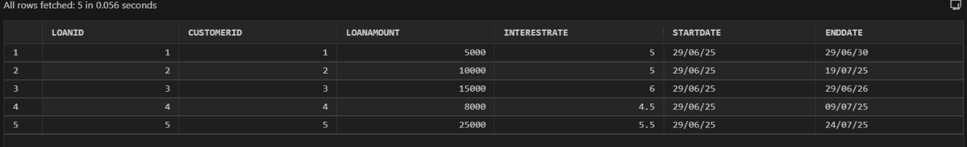

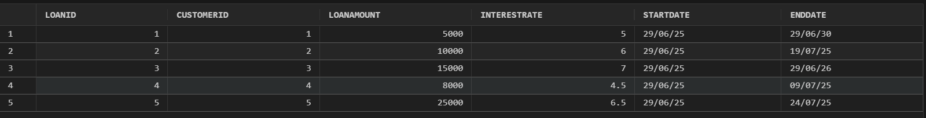

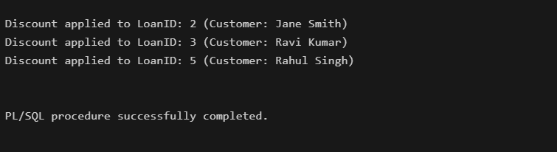

* 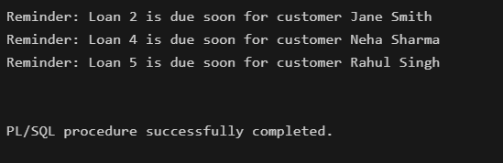**REMAINDER FOR LOAN OUTPUT**
* **VIP_FLAG**

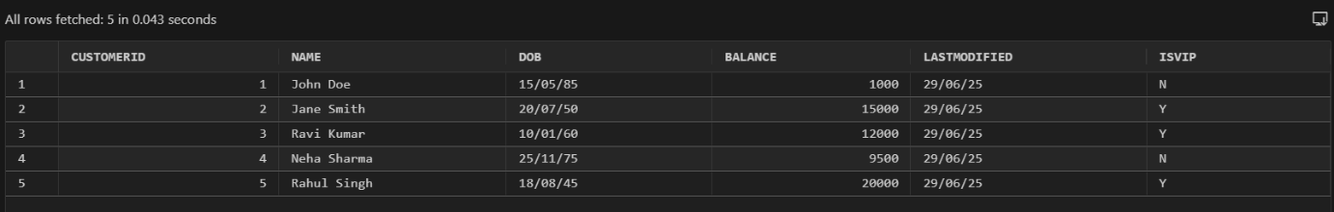

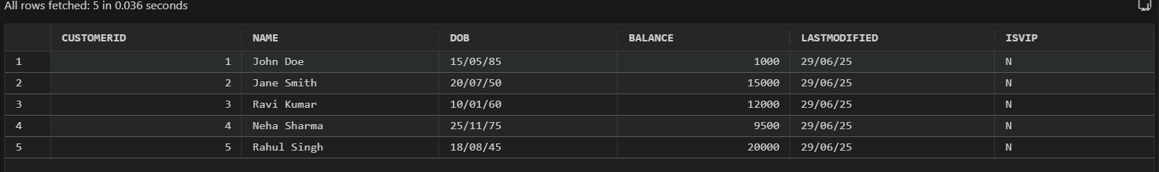

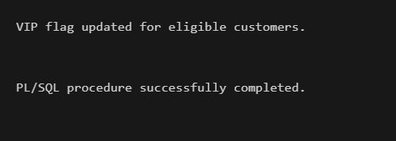

**STORED PROCEDURES**

* **PROCESS MONTHLY INTEREST**

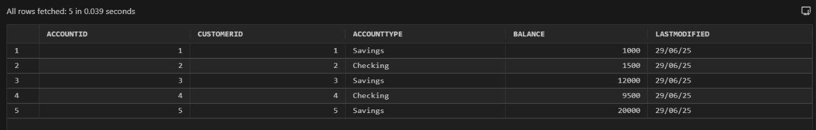

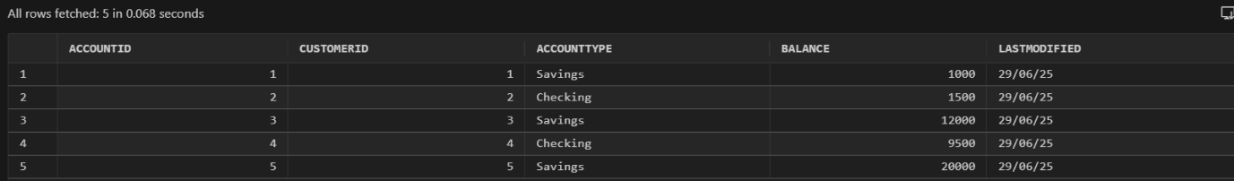

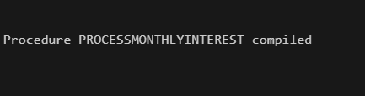

* **TRANSFER FUNDS**

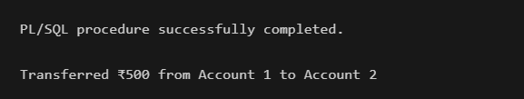

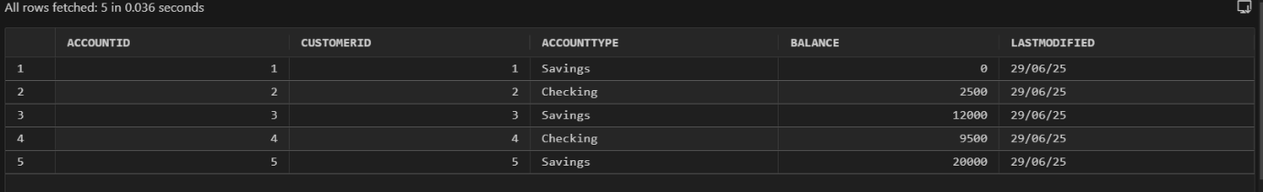

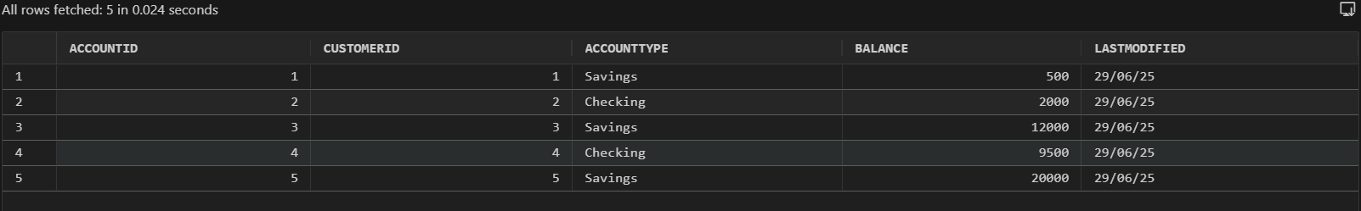

* **UPDATE EMPLOYEE BONUS**

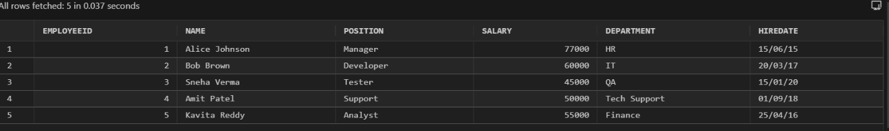

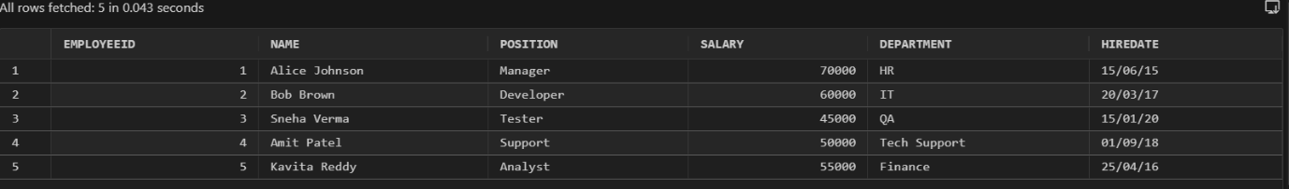

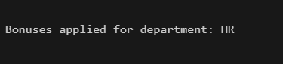

**JUNIT_BASIC TESTING OUTPUT**

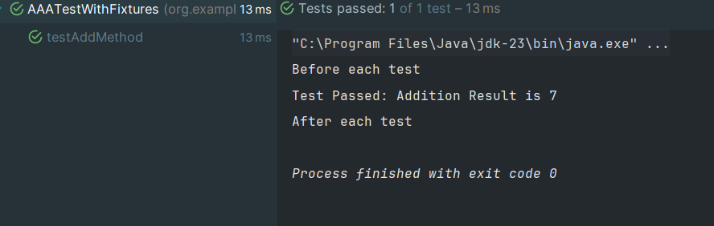

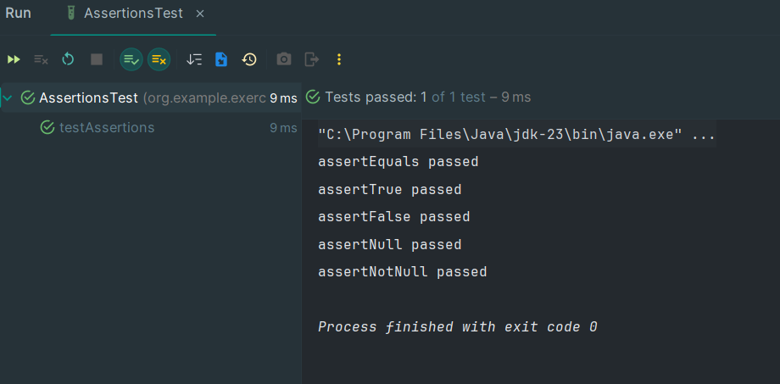

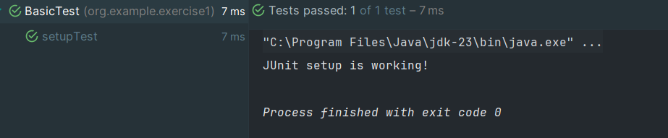

**MOCKITO EXERCISES**

* **MOCKING AND STUBBING**

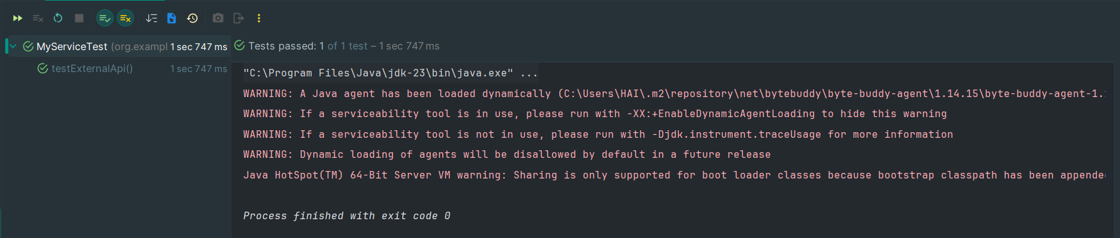

* **VERIFYING INTERACTION**

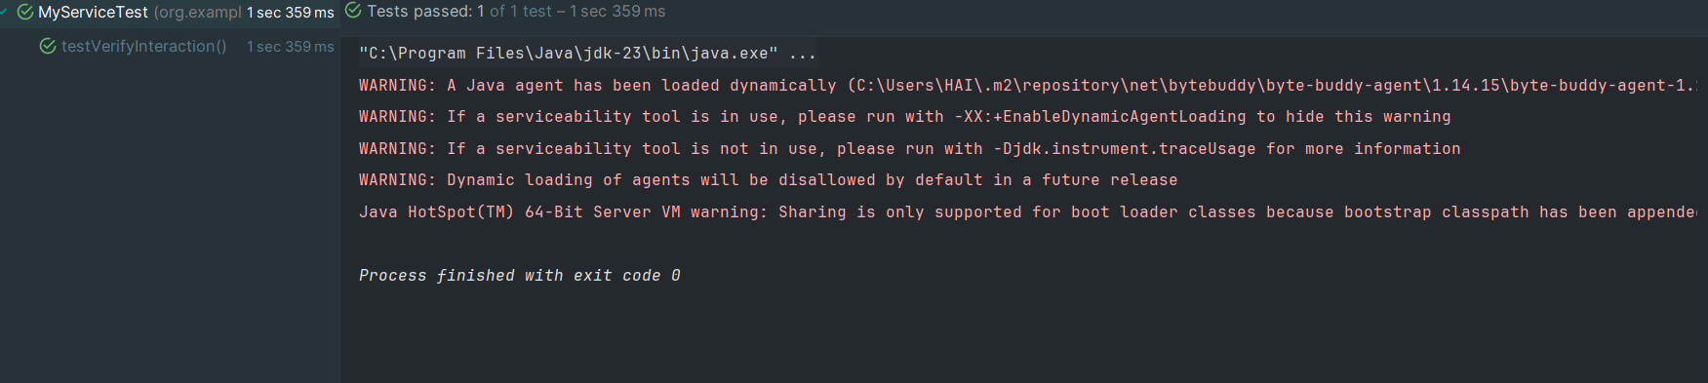

**SL4J LOGGING EXERCISES**

**EXERCISE 1: LOGGING ERROR MESSAGES AND WARNING**

